Caden Clack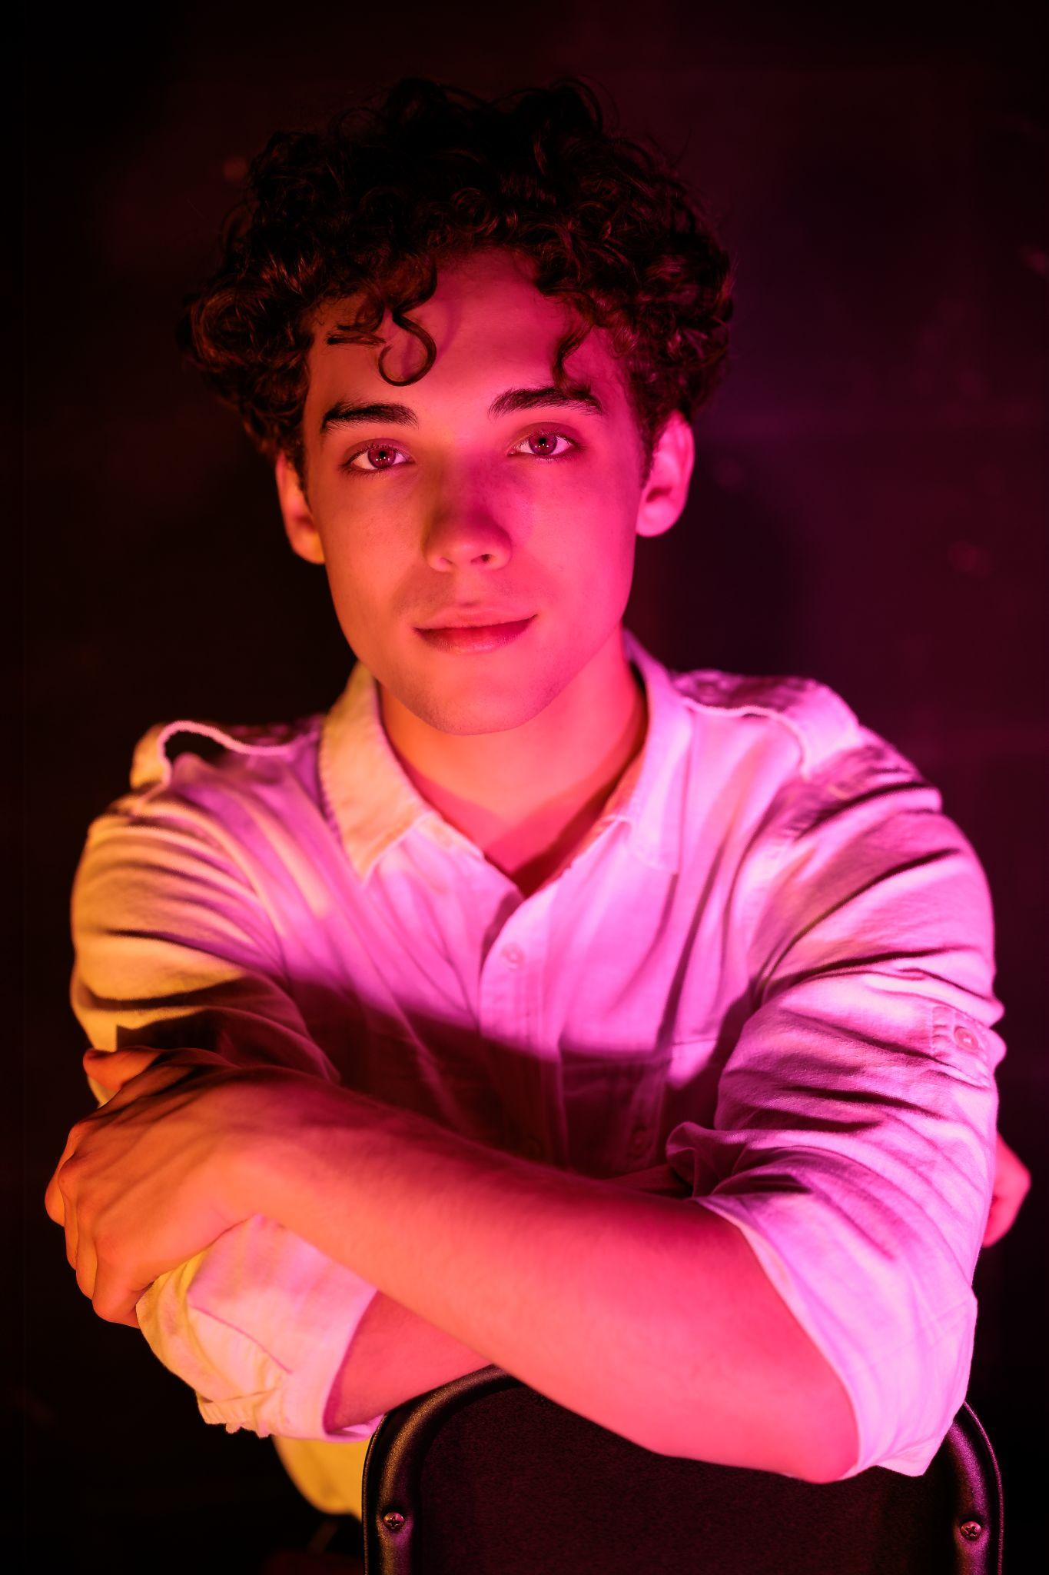

cadenclack@gmail.com

Senior

The University of Texas at Austin

This year I worked on designing the Junkyard, Laboratory, Cave, and City maps. Creating these maps involved editing the lighting for natural and artificial effects, sculpting landscapes, programming objects for the player to interact with, finding assets, and creating materials. The process in creating these maps involved balancing the functional needs of the story creators and my own creative choices.